Python Project Report

Project 5: roll no [15,16,17] G1

The task is to create a script that generates a random number between a fixed range, and if the user guesses the number right in three chances, then user wins otherwise user lose. This game user can play as many numbers of times and whenever user wins a score is to be given to the user.

BACHELOR OF TECHNOLOGY

Computer science and Engineering

Submitted to

Dr. Makul Mahajan

LOVELY PROFESSIONAL UNIVERSITY

PHAGWARA, PUNJAB



SUBMITTED BY :-Yarram.Indrasenareddy Reg.No:-12214979 RollNo:15

SUBMITTED BY:-Suluguri.Aravind goud Reg .No:-12215093 RollNo:16

SUBMITTED BY:-Biradar kiran kumar swamy Reg.No:-12215137 RollNo:17

ACKNOWLEDGEMENT

Project is only possible because of my mentor and

my Prof. Dr. Makul Mahajan Sir and We would like

to thanks him from depth of our heart for giving us

knowledge of Python and for also giving me so many

advices and various more inputs in this project. And

also We want to say thanks to my all friends and

family who gave me so many wonderful feedbacks in

this project. And lpu university for the daily python

test by this test I have improved my skills a lot.

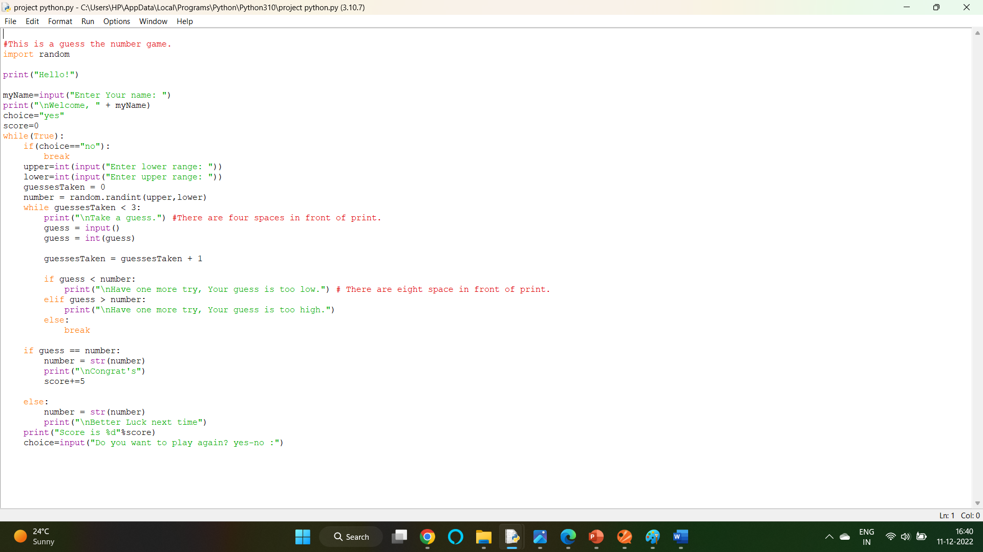Input:

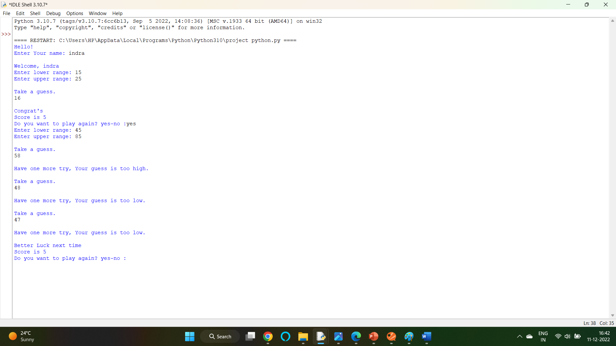Output:

conclusion

We hope and we wish that this document

will help you to understand about our

minimalist but attractive project as I had

tried something different from usual. We

had used Python for logical.

Reference:

1.W3school

2.Google

3.Youtube

Thankyou